**Project development phase : Delivery of Sprint -4**

|  |  |
| --- | --- |
| **Date:** | **17 November 2022** |
| **Team ID:** | **PNT2022TMID48076** |
| **Name:** | **Real-Time River Water Quality Monitoring and Control System** |

**Python program:**

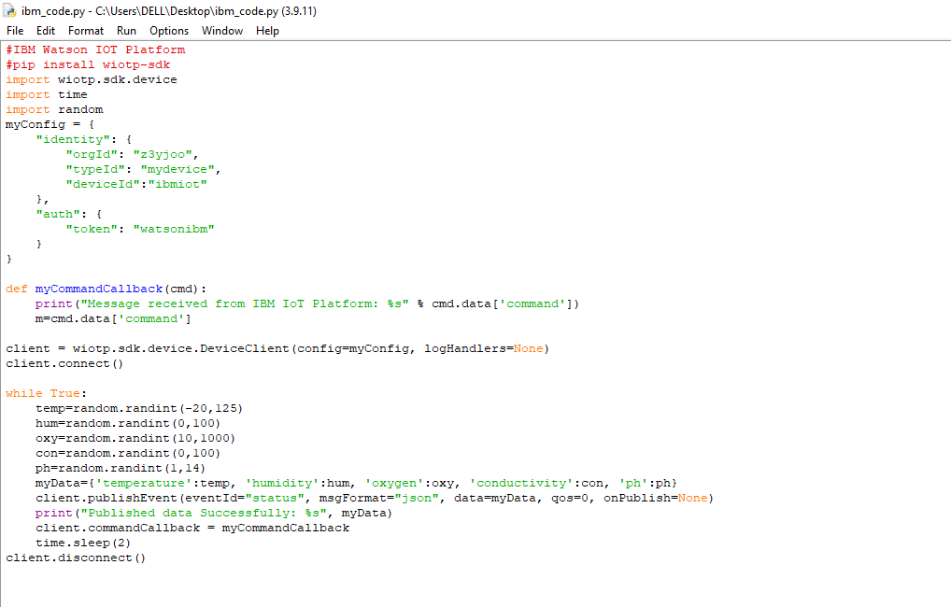

**Simulation :**

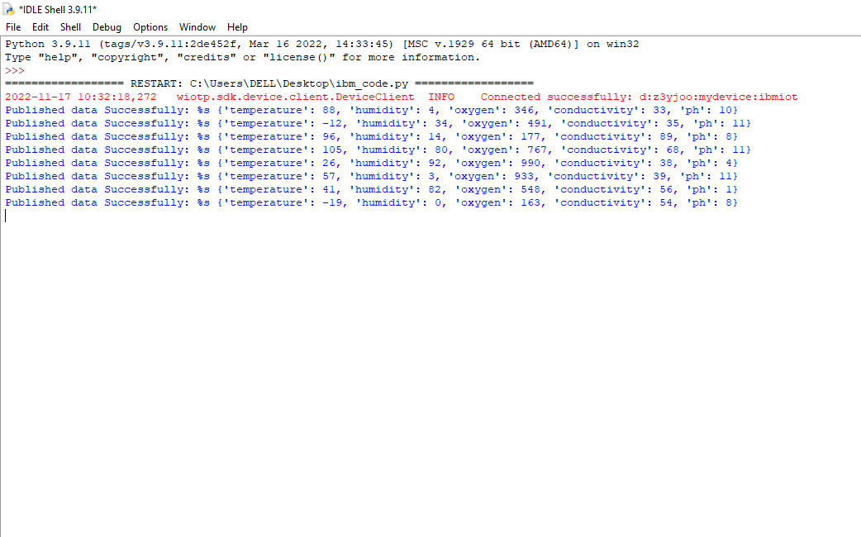

**Connected with IBM Watson Iot:**

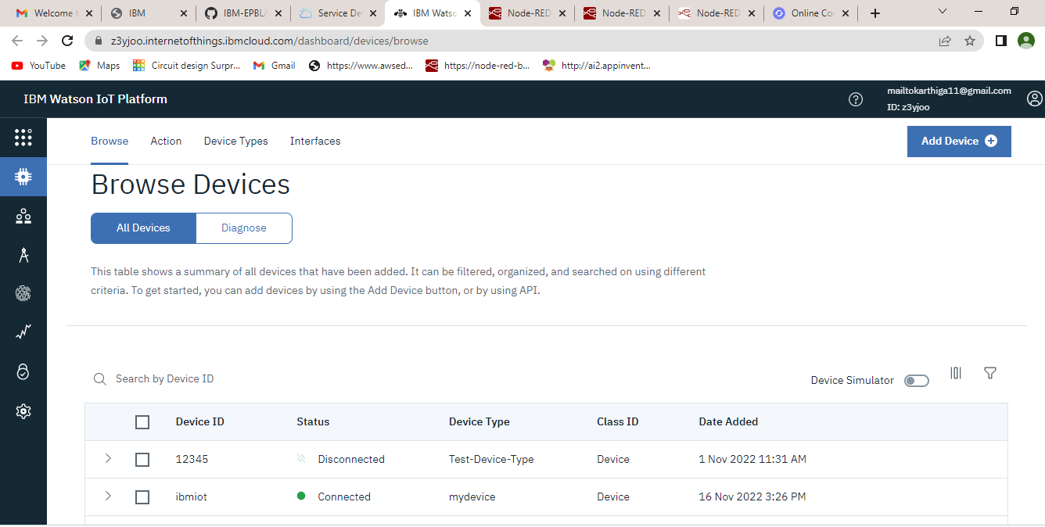

**Data delivery of IBm Watson IoT:**

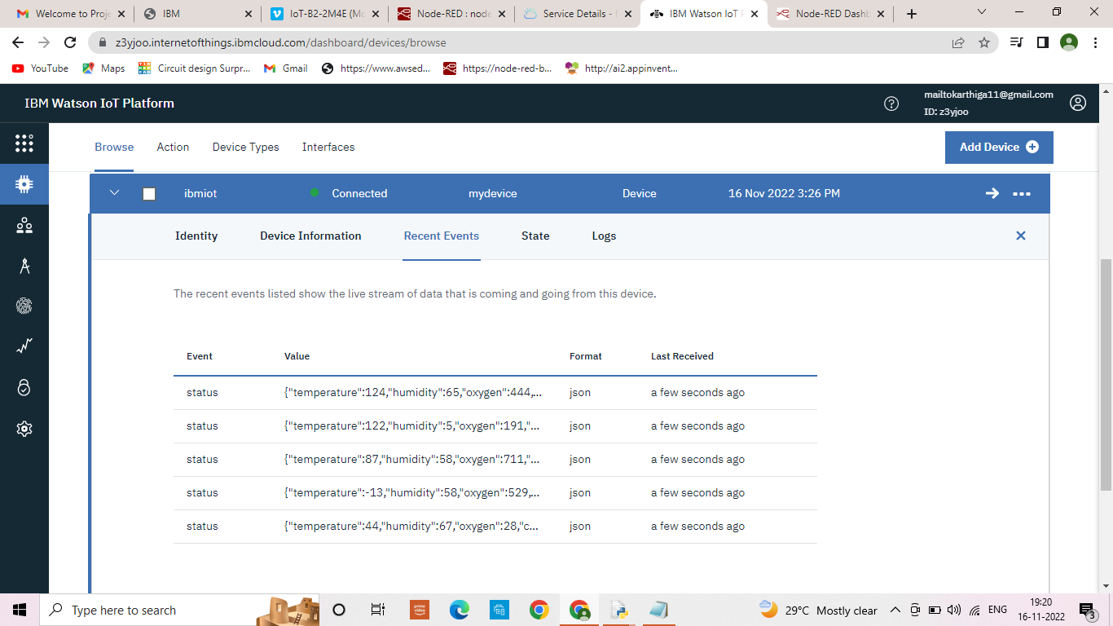

**Node red connection:**

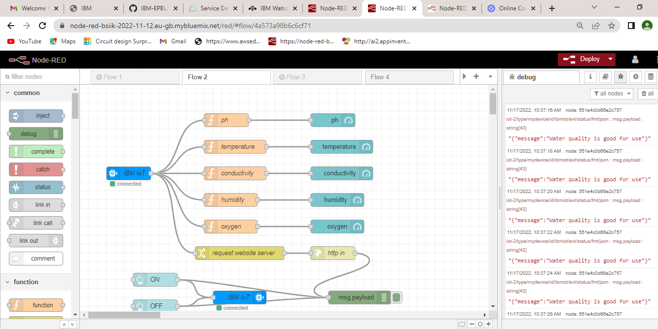

**Message delivery of node red:**

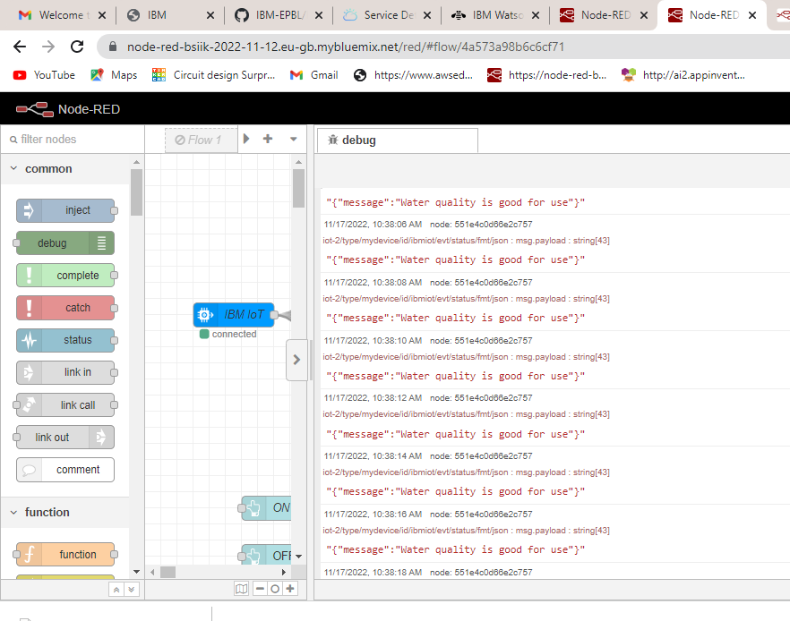

**Mit app :**

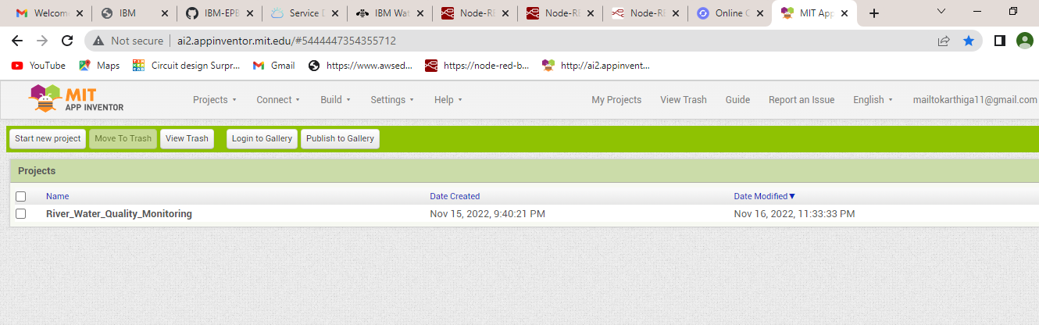

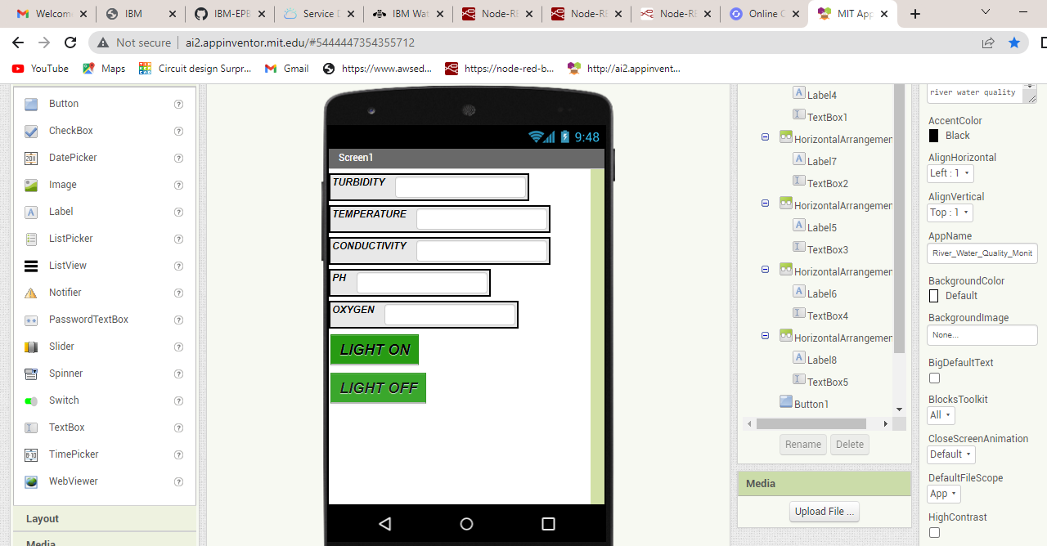

**Connection with mobile application:**

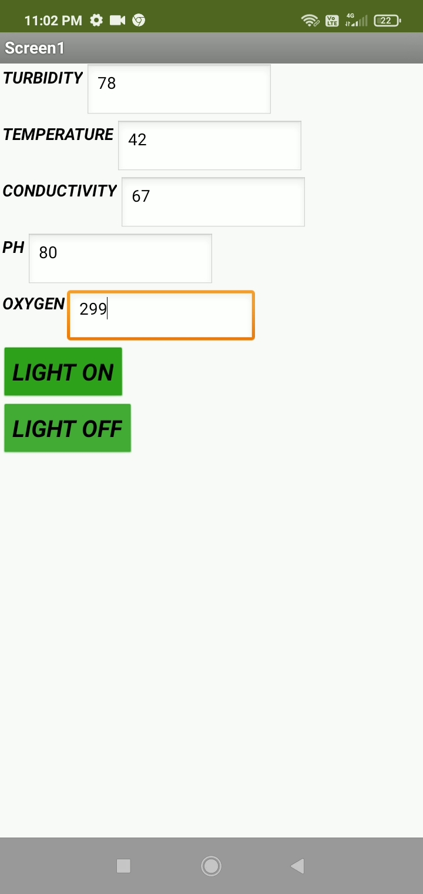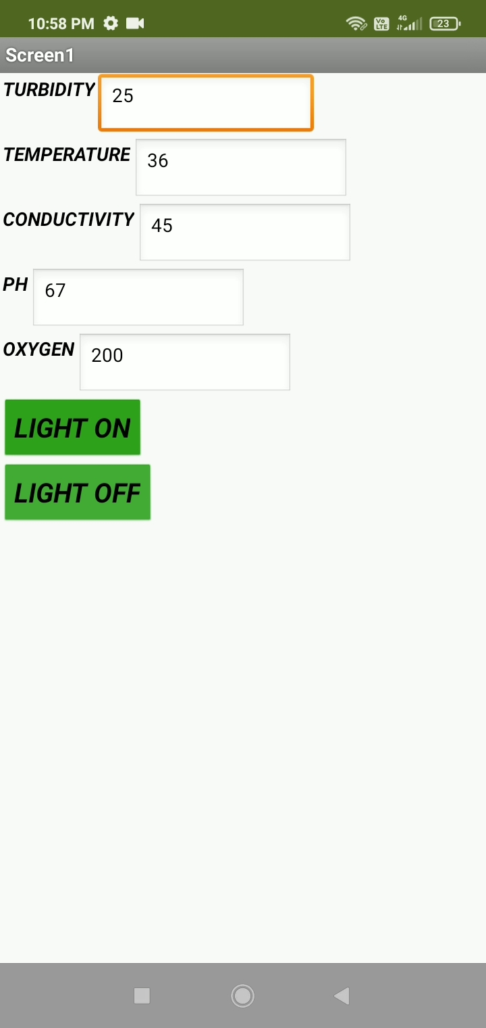

**Jira software tool :**

**App delivery road map:**

